**CSC5991**

**August 2, 2023**

**Group 3 – Movies at a Glance**

**Group Members:**

Taraque Ahmed

Aarti Pandya

Amanda Stead

Pamula Avinash

Ankith Goutham

Report. (25 points). To be submitted before the final presentation.  This report will include the following:

* All information from the proposal (modified to reflect the final outcomes).
* Flowcharts.  – Amanda
* Project outcomes. - Taraque
* Screenshots of the outcome.  – Everyone
* Goals achieved, and remaining goals.  -  Aarti
* Team member roles and contributions. - Ankith
* Github, Trello (or the Agile tool you used), container registry addresses.  - Pamula

**Screenshots of the outcome.**  
  
Movie Titles: Amanda Stead

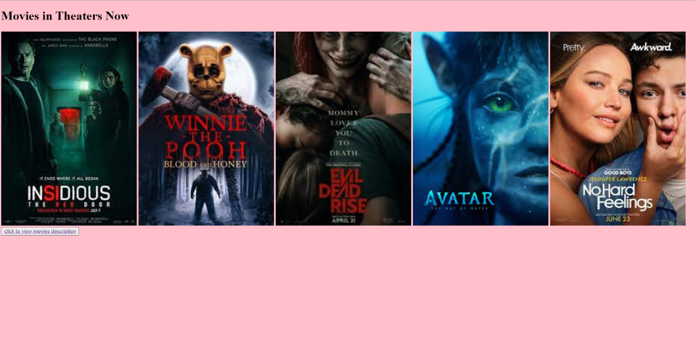

Description page: Avinash Pamula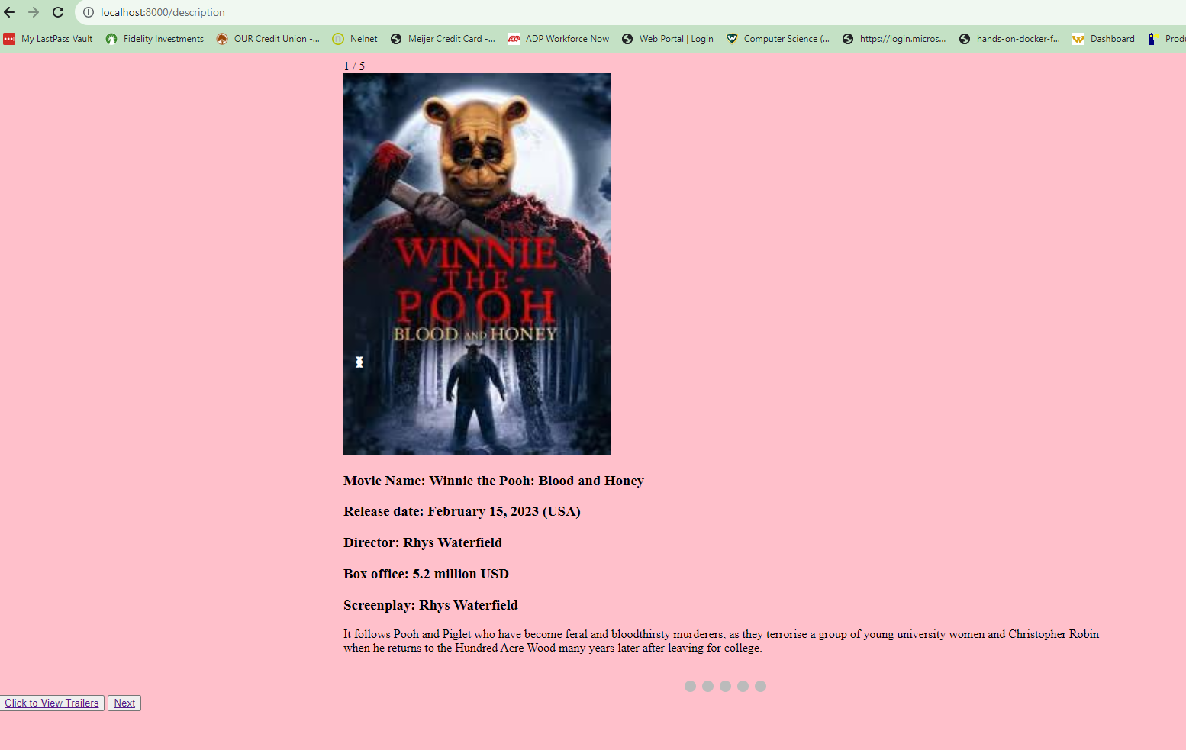  
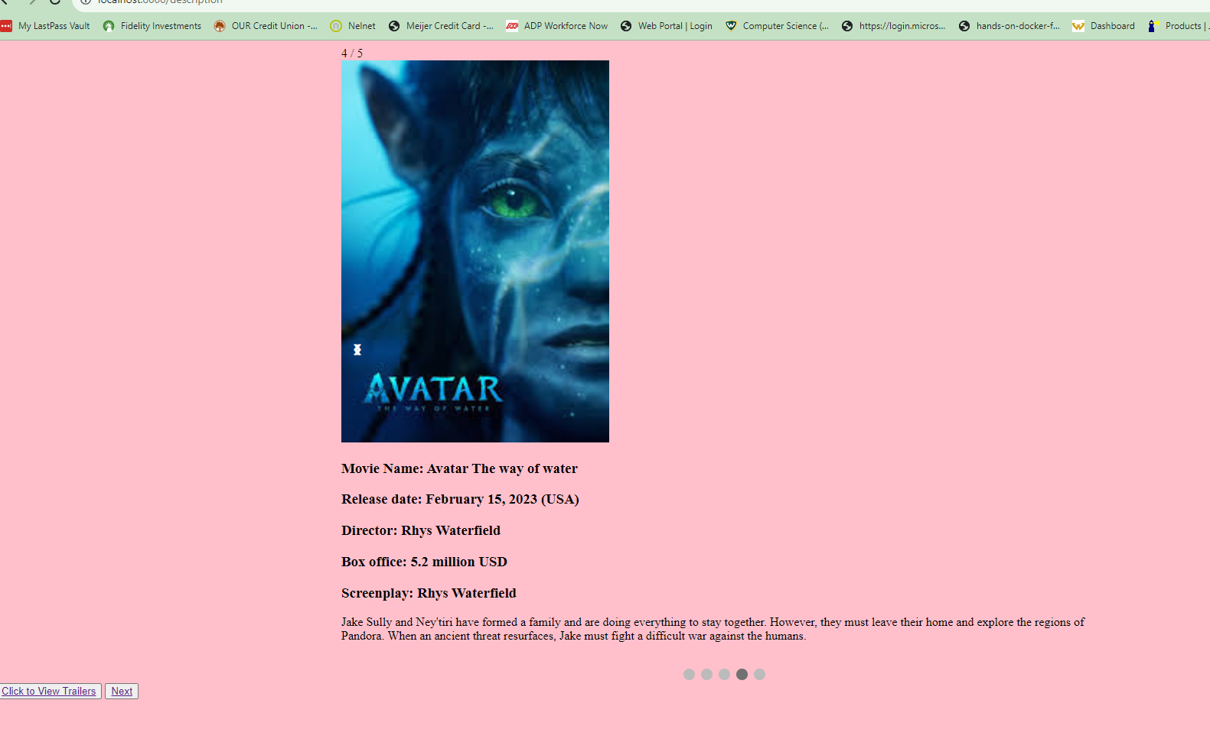

Location: Aarti Pandya

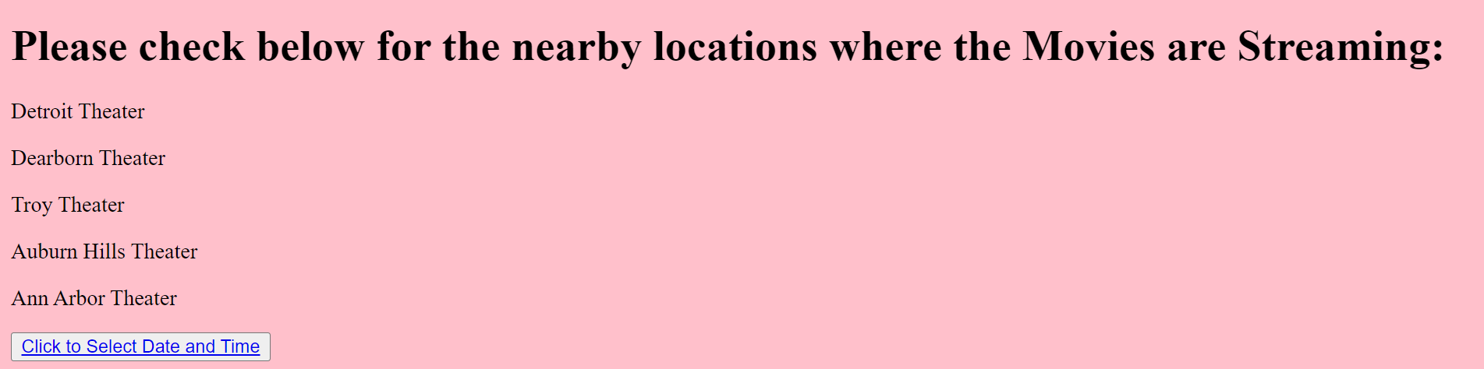  
Seat selection: Avinash Pamula  
  
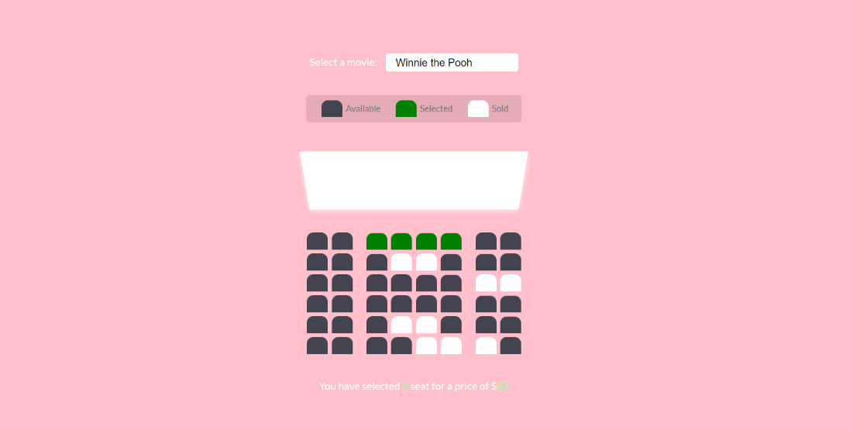  
  
  
  
DateTime.html(Ankith Goutham):  
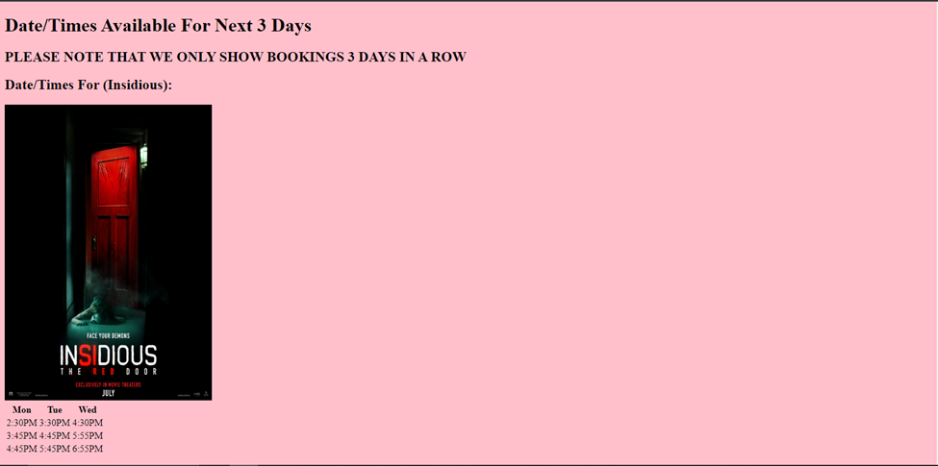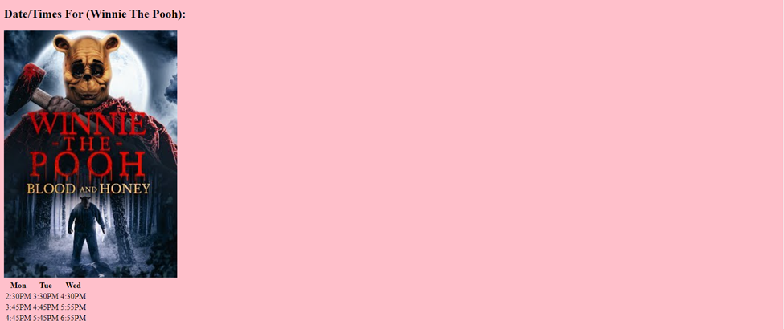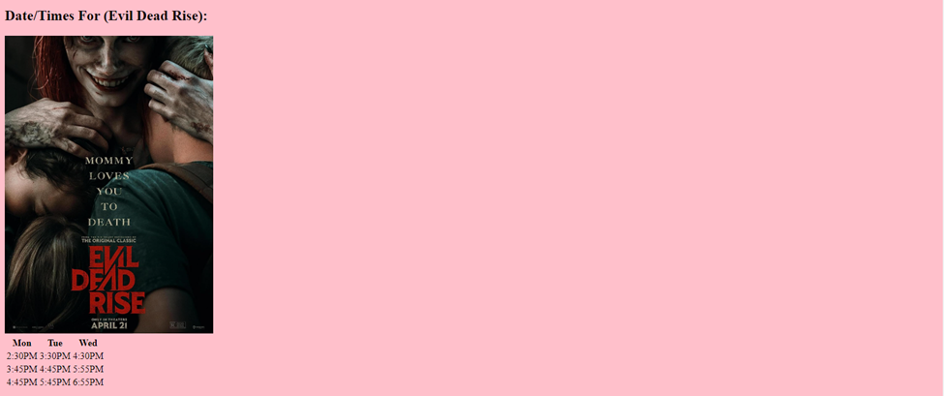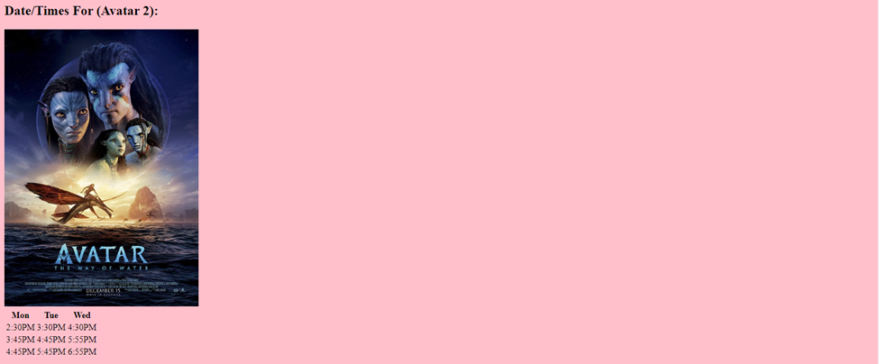

Booking Details: Aarti Pandya

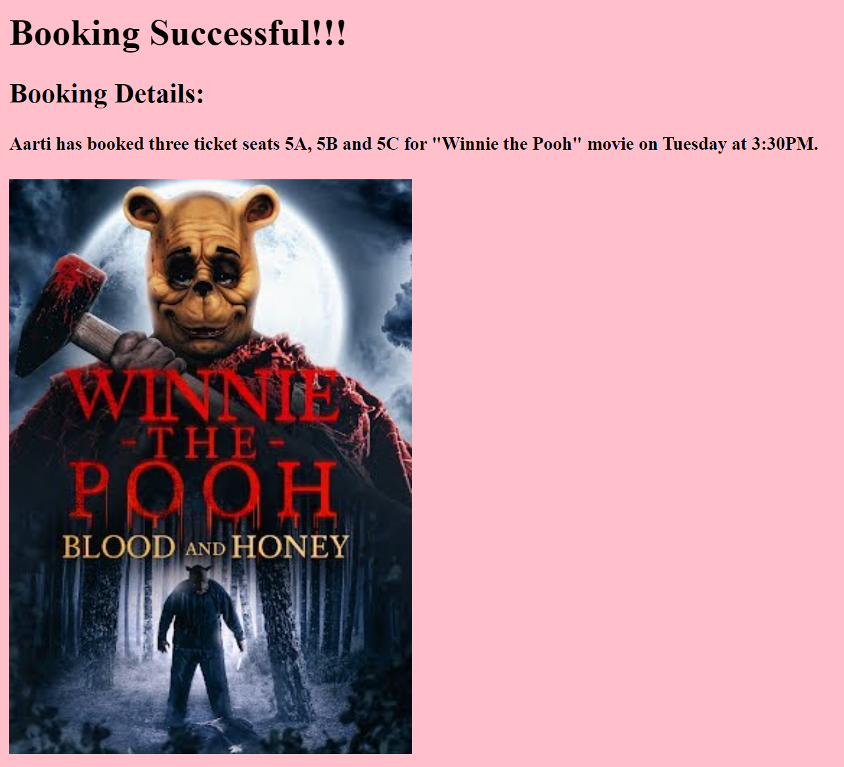

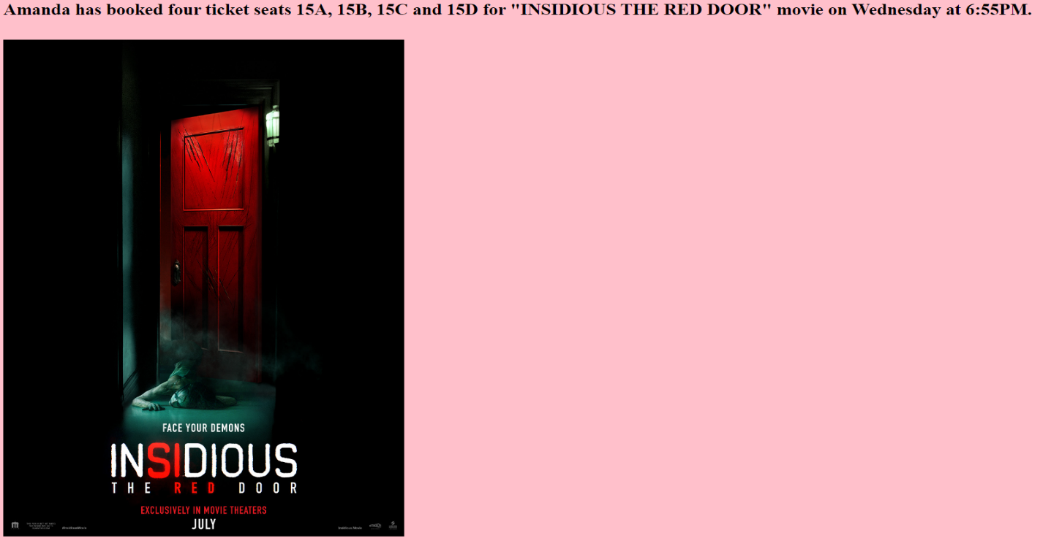  
  
  
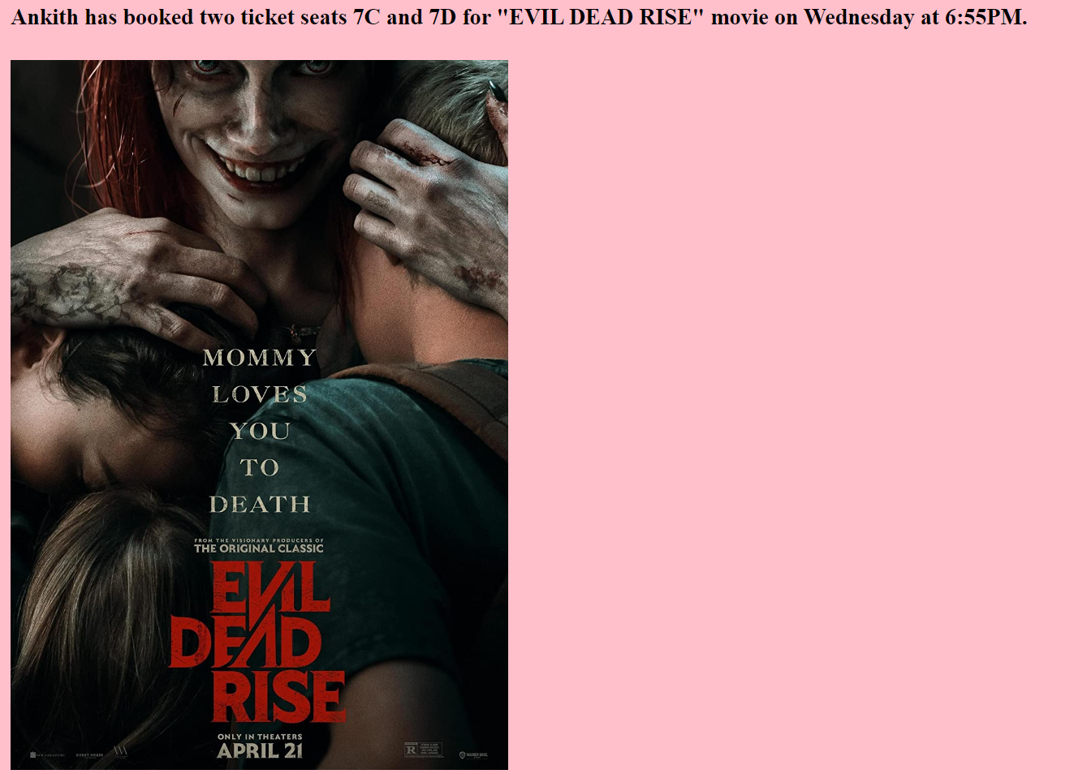

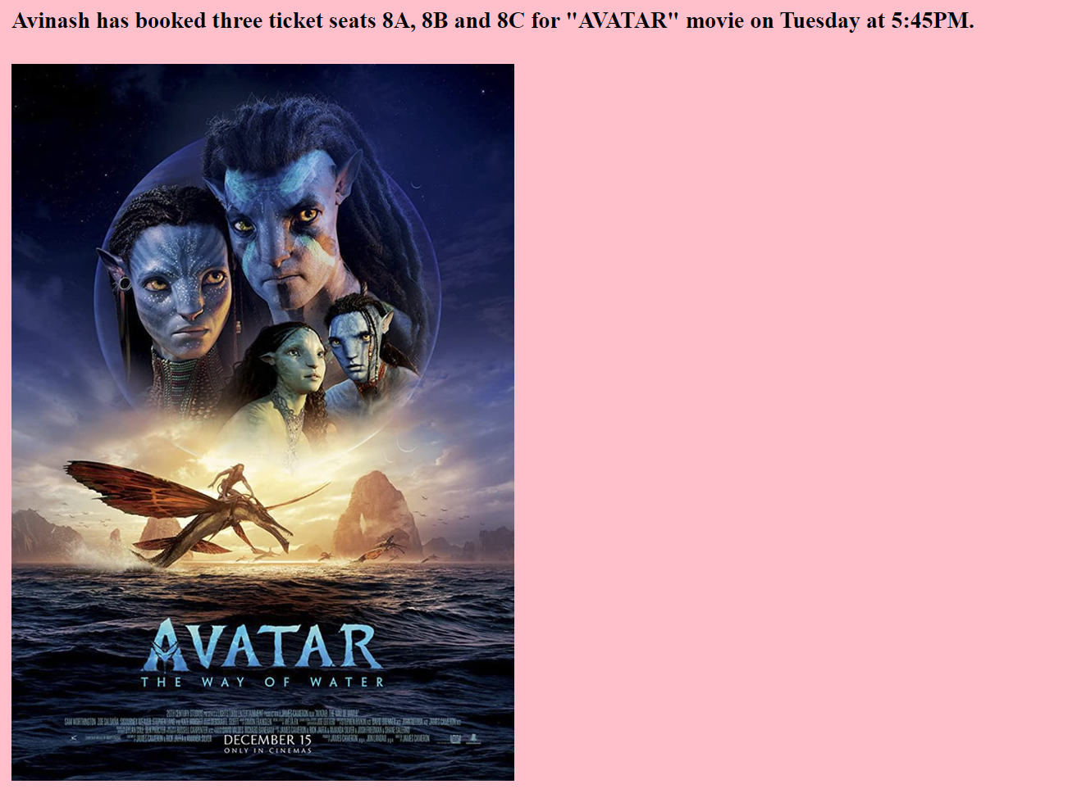

  
  
  
  
Snacks.html(Ankith Goutham):

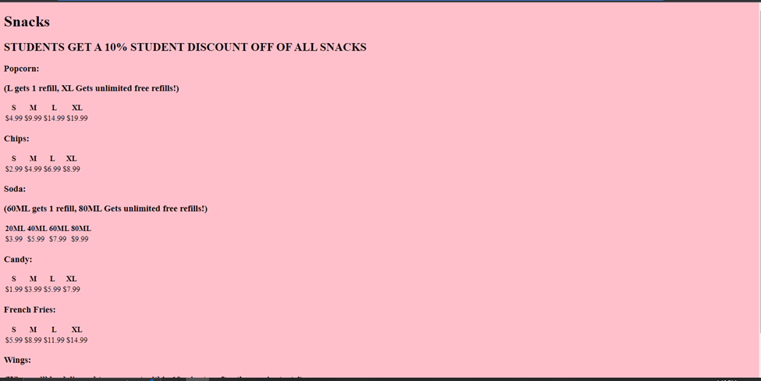

Receipt: Amanda Stead

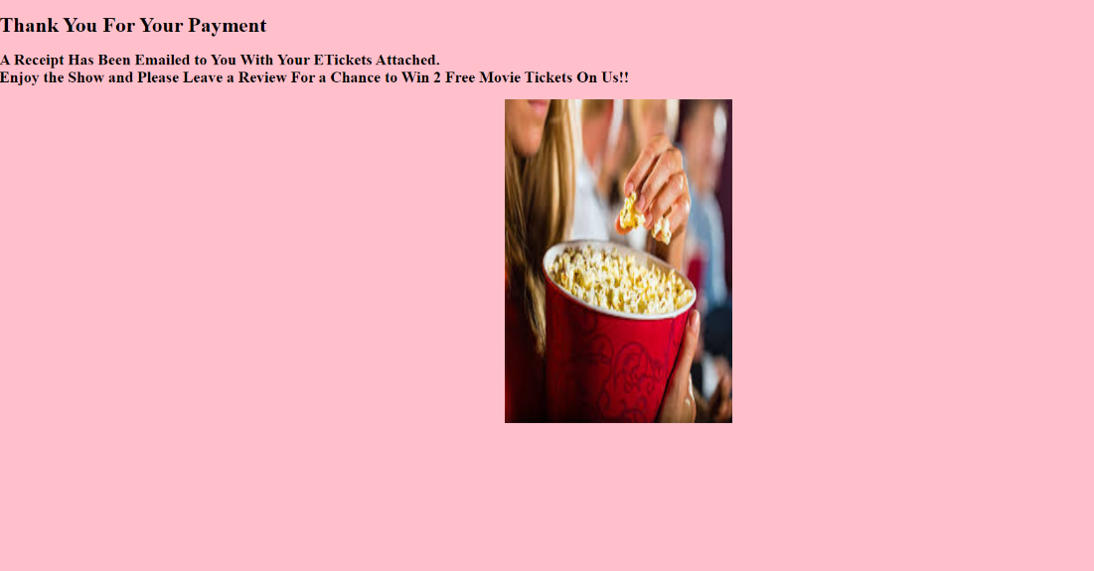

Payment: Taraque Ahmed

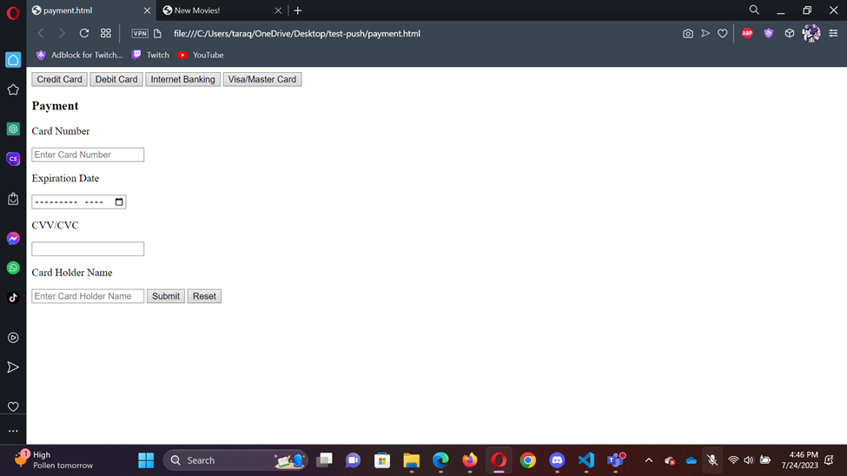

Trailer: Taraque Ahmed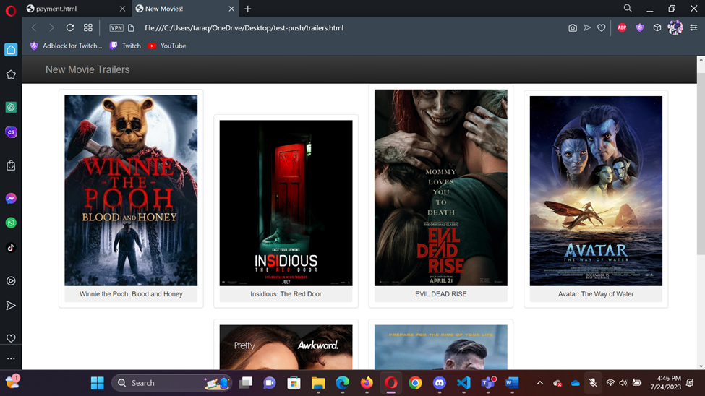

Kubernetes: Amanda Stead

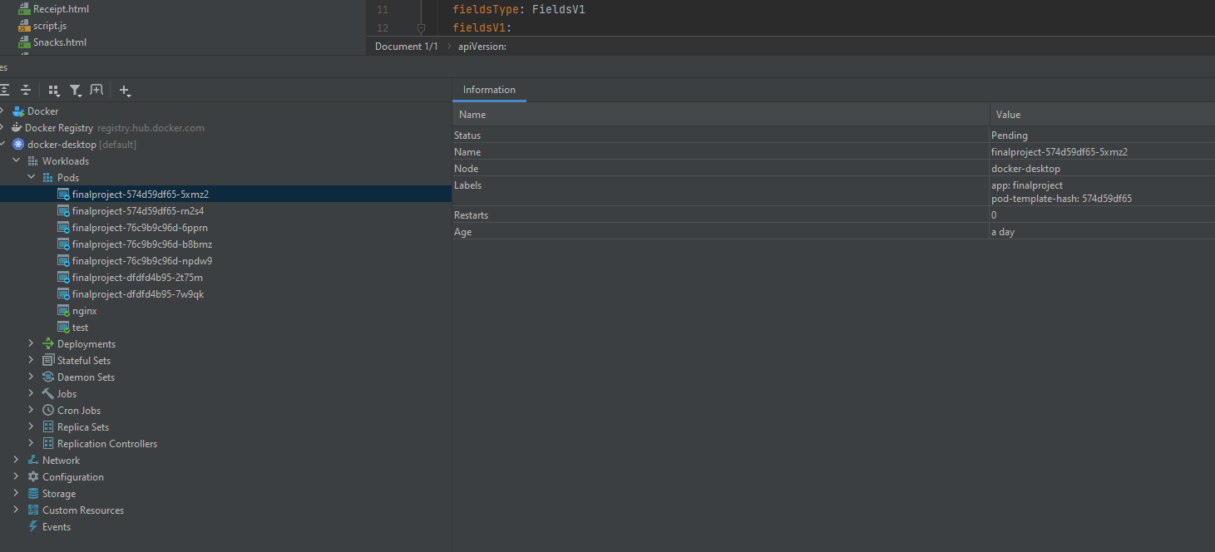

Jira : Avinash Pamula  
  
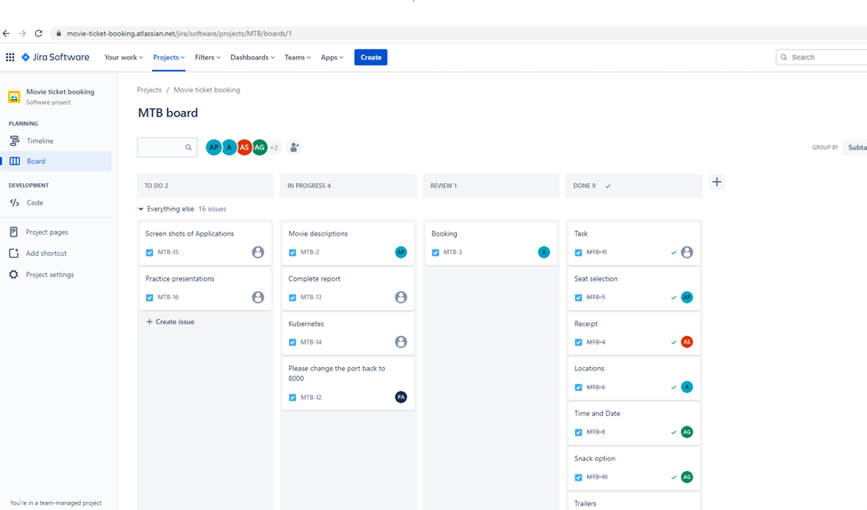  
  
  
Flowchart – Amanda Stead

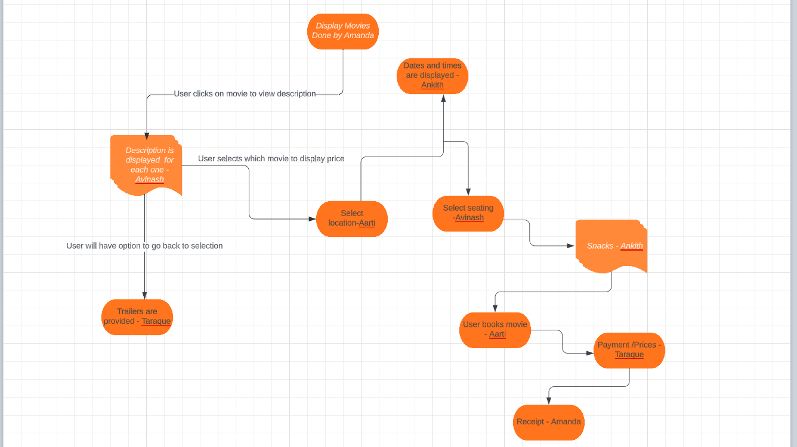

**Projects Outcomes**

The "Movies at a Glance" project sought to provide a comprehensive and user-friendly movie recommendation system to aid users in finding new movies that suit their tastes and interests. Data gathering, system design, programming, testing, and deployment were a few of the processes that the project went through. And The "Movies at a Glance" project achieved its main goals by creating and deploying a user-friendly movie recommendation system. The application has the potential to become a top resource for movie lovers to find and explore a large selection of films that cater to their tastes with ongoing development and future suggestions.  
  
  
  
  
**GITHUB : Avinash Pamula**  
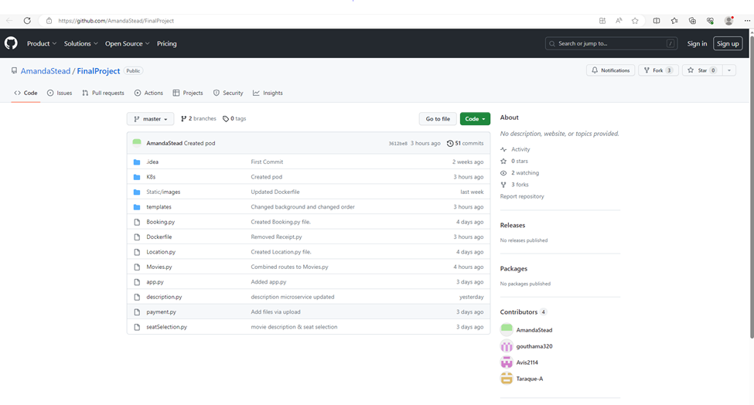

**Goals Achieved**

* Successfully created ten different microservices which will be helpful for booking online tickets for movies.
* We have added following different services in our application:
* Display Movies
* Movies Description
* Trailers
* Location
* Select Seating
* Booking
* Payment
* Dates/Times
* Snacks
* Receipts
* Created a flowchart for better understanding of our application “Movies at a Glance”.
* We have used “Jira” agile project management tool for tracking our work items and project progress.
* We have created a report which contains all the basic details of our applications as well as our contributions.
* We have made power point presentation to give an in-depth understanding of our project.
* We have successfully fulfilled all the requirements of our project.

**Remaining Goals**

* We were not able to make our application more interactive due to time constraint.
* We wanted to make our application more appealing but were not able to do so.
* We could have added more services to our application which can make our application more user friendly but due to short period of time were not able to do so.

**Team Member Roles and Contributions:**

With the project based around 10 microservices, and our team being 5 members, we were tasked to do 2 microservices per person. Starting from the top, Amanda Stead did Display Movies (Titles) and receipt, Pamula Avinash did Movie Descriptions and select seating, Aarti Pandya did Booking and Locations, Taraque Ahmed did Trailers and Payment, and I, Ankith Goutham, did Dates/Time and Snacks. Amanda Stead was elected as group leader, and scribe, meaning she would write down all our ideas on a document, and sent out team meeting links. Whilst we did all that for the microservices, we also had to work on the written report. Each member was tasked with one section. Starting from the top, Flowchart was created by Amanda, Project outcomes was created by Taraque, everyone was responsible for screenshotting their own microservice, Goals achieved and remaining goals was created by Aarti, Team member roles and contributions (This portion of the report we’re on right now) was created by Ankith, and Github container registry address was created by Pamula. Each team member joined the meetings on time and were expected to update based on what new work they had done on their microservices. All these microservices were then to be pushed to the master repository, hosted on Amanda’s Github. All the changes and such were to be committed, and there was a list of goals to be reached by every meeting. We met every Monday/Friday at around 4-5. This was due to all of our schedules only leaving those days as free. Avinash started on Jira, which all the team members tracked the progress of the project.

From the proposal, we as a team building a movie ticket booking basic application with holds 10 microservices with some required UI. Amanda worked on the Movie titles page which had a button to redirect to the description page on which I, Avinash worked along with seal selection. Arati handled booking and locations. Taraque takes care of Trailers and Payments. Ankith developed microservices for Date, time and snacks.   
  
We created a Git repo and committed and pushed our code individually to GitHub. We also maintained Jira software for our project. Created tasks in Jira under our project and assigned tasks to respective team members and tracked the status of work. We also added our git rep to Jira software. We also containerized our project in docker hub and utilized Kubernetes, which was done by Amanda Stead

**Agile methodology used: Jira**

**Links to Resources**   
   
Git repo - <https://github.com/AmandaStead/FinalProject.git>

PowerPoint: <https://waynestateprod-my.sharepoint.com/:p:/r/personal/hc7216_wayne_edu/Documents/CSC%205991%20Presentation.pptx?d=w14803f7293cb4541959f80698a47e039&csf=1&web=1&e=2DgBGw>

Jira - [https://movie-ticket-booking.atlassian.net/jira/software/projects/MTB/boards/1 (accessable to team members only)](https://movie-ticket-booking.atlassian.net/jira/software/projects/MTB/boards/1(%20))   
Docker hub - <https://hub.docker.com/repository/docker/amandastead44/finalproject/general>

docker push amandastead44/finalproject:latest

Flowchart: <https://lucid.app/lucidchart/b75bce07-4012-43be-a61a-627cefb997e1/edit?viewport_loc=-39%2C-16%2C2219%2C1047%2C0_0&invitationId=inv_e9ae3d52-c58e-4efc-bd11-fee93194ff44>